COS30045 – Data Visualisation

Personal critique on data graphs depicting changes in cost of living in Australia

Name: Huu Ti Dang

(104101363)

Swinburne University of Technology

COS30045 – Data Visualisation

Friday 12:30 – 2:30

Instructor: Shalmoly Mondal

([shalmolymondal@swin.edu.au](mailto:shalmolymondal@swin.edu.au))

Word count: 1629

Date: 2/04/2023

**Executive Summary**

The purpose of this report is to showcases the critique of multiple visualisations and explaining the changes in cost of living. This report will highlight the importance of data types and their use cases, how data correspond with one another, comparing data from regions to regions, praising the good and outlining bad of each representation.

The report also provides background, motivation and purpose in the introduction and provide details for the many visualisations that was chosen. In the body, we will be going over the data types, critiquing their visual, stating their advantages and limitation, and suggesting any improvement.

**Table of Contents**

**Executive Summary…………………………………………………2**

**1. Introduction………………………………………………………4**

*1.1. Background and motivation……………………………………………4*

*1.2. Visualisation purposes……………………………………………………4*

**2. Body………………………………………………………………….4**

*2.1. The state and causes………………………………………………………4*

*2.1.1. Factors that cause these changes……………………………5*

*a) Internal factors…………………………………………………………5*

*b) External factors…………………………………………………………5*

*2.1.2. Comparison between nation…………………………………6*

*2.2. Data types and visual presentation……………………………………6*

*2.3. Effectiveness of the visualisations………………………………………6*

*2.4 Limitations of the visualisations…………………………………………7*

*2.5 Suggested improvements………………………………………………….8*

**3. Conclusion…………………………………………………………8**

**4. References…………………………………………………………8**

**1. Introduction**

*1.1. Background and motivation*

For many years now, we have been experiencing financial, political and climate issues. Lately, it been taking a toll on many citizens across the world, especially blue-collar workers. So, as a Data Scientist, I will be giving my critique on 2-3 visual presentation on the matter, get a broader understand on why this is the case, finding reason for the changes, and what relation causes this trend, etc.

To do so, I will be looking mainly at the Oceania region, where in the last decades are so, Australian are seeing a upwards trend in prices while their wages are still a constant. It may be due to internal catastrophe like the Australian Wildfires back in 2019, the housing crisis, inflation etc, or external causes, which will be contextualised in this report.

*1.2. Visualisation purposes*

**Primary goals:**

* Finding the causes of changes in the cost of living?
* Finding the impact it has on citizens of Australia
* Comparing Australia cost of living to other nations.
* Comparing it to the cost of living in Australia a decades ago
* Give out details reports while still being able to

explains it to a less experience audiences.

**2. Body**

*2.1. The state and causes*

Before we could start giving our opinion on how to go about visualising the cost of living, we must have our references. So first and foremost, we will be looking at the figure below, which depicts the rising price of petrol compares to other expenses.

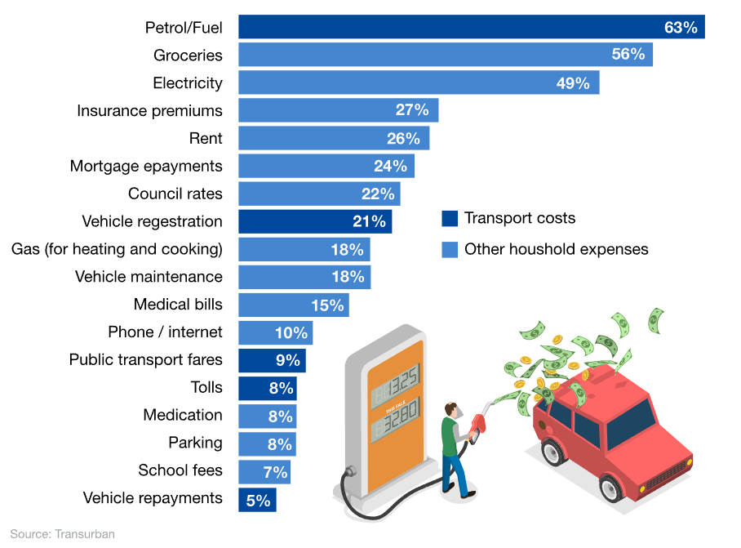

Figure 1: Prices of transport compares to other common expenses.

Even though in this reference by News, it is mainly talking about how fuels prices are the main concerns for Australian. Alternatively, we could also see how much percentage other expenses take up, with Petrol being first taking up 63% of citizens income, then Groceries and Electricity taking second and third with 56% and 49%. Funnily enough, school fees are at the bottom with only 7%, however seeing this graph would give us a rough idea on how much expensive everything had gotten.

*2.1.1. Factors that cause these changes*

*a) Internal factors*

The most renounce causes to the changes in cost of living would be inflation as it is an ongoing problem for Australia for many years now. Display in this graph we can see how it would correspond with the changes many citizens are seeing.

Figure 2: Australia inflation rate from 2020 to 2023

As we can see from this bar chart, Australia annual inflation rate climbed from 7.3% in Q3 of 2022 to 7.8 to Q4 of 2022, which related nicely to our first figure. Which prove why prices increased further for transport (8.0% vs 9.2%), housing (10.7% vs 10.5%), alcohol & tobacco (4.4% vs 4.0%), furnishings (8.4% vs 7.7%), recreation (9.0% vs 5.0%), health (3.8% vs 2.7%), and insurance & financial services (5.0% vs 4.2%).

*b) External factors*

In recent year, the world was hit by 2 waves of covid. In Australia case, covid cases has skyrocket ever since December of 2021, from what we can see from the graph.

Figure 3: confirmed covid cases of 8 countries.

Around December and January of 2022, the amount of confirm cases has risen to over 4000, with the same around February and March. This had cause major lockdown for Australia. And to combat this the Australian government had to send out stimulus check and increase worker salary to enticed them, which resulted in inflation and increase prices in living standard.

*2.1.2. Comparison between regions*

We are going to be focusing mainly on Australia and its neighbouring countries, to get a brighter idea on how high Australia living standard is. So, we will mostly be going through the Southeast Asia region and the Oceania region.

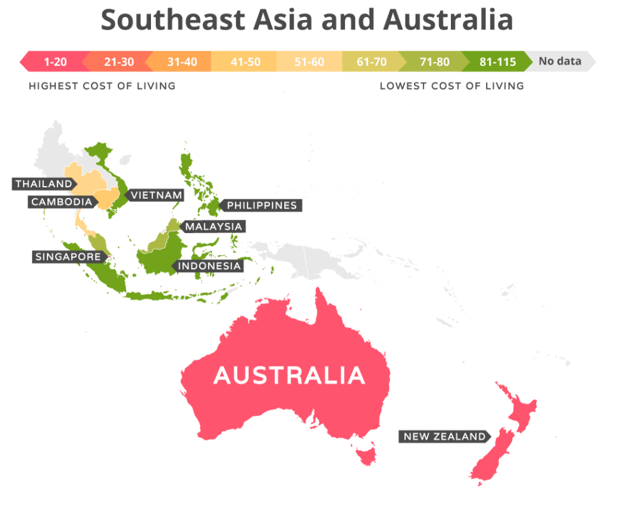

Figure 4: Cost of living between SEA and OCE

As we suspected, Australia highlighted in red indicates its high living standard compared to its counterpart the Southeast Asia, which are mostly in green.

*2.2. Data types and visual presentation*

In this report, we can see multiple variety of visualisation for different ways to interpret changes in dataset, such as bar charts, line graphs, which the most noticeable, which is the uses of a choropleth map, which uses different colours to compare data values between regions.

Most of these uses quantitative, nominal and ordinal data to represent inflation rates, confirmed covid cases, cost of living indexes and colour-schemed maps for comparison.

*2.3. Effectiveness of the visualisations*

The bar chart display in figure 1 depicts the percentage of concerned Australian about changes in cost-of-living expenses, which is cost of fuels and groceries, with 63% and 56%, correctly citing citizens’ concerns.

Additionally in figure 2, which present us with the inflation rate of Australia from over time, with clear labels, simple colour scheme to showcase positive and negative values.

The use of bar chart both had it upside and downside, with the upside of being easy to explain, easy to get a grasp of and is it familiar to most if not all audiences. With the x-axis mainly for labels, and the y-axis for value, which help users interpret the data more easily. This would then help the users to make relationship corresponding to the changes in cost of living between the two.

We then move on to the third figures, which showcases the number of confirmed cases in Australia, we use a line graph covid is a ever changing disease and we need to keep track of it trends and patterns over time. The line graph consists of the x-axis, which represent the changing time such as days, months or years, and the y-axis represent the measured data, then the value will be recorded every interval to form a line. This type of visual helps user sees the rate of covid infected more clearly.

Last but not least is the choropleth map in figure 4, which we used to compare data across regions and countries, it uses colour shading to represent these values. And they are assigned based on how high or low their living standard are. This type data representation, help the user visualise data across large regions, that are highlighted to displays differences and patterns, which are easier to interpret than a dataset with number when it comes to geographical location.

*2.4 Limitations of the visualisations*

Most of the above visual are represented using bar charts, however, they still poses many limitations. As they need further analysis, due to not having enough details, they can only use for nominal or ordinal dataset. Their inability to display complex data and trend, that is why the changes to cost of living is only for one year.

The line graph, on the other hands provide limited information as it is only showing one variable, which is confirmed cases and not other such as death or recovery cases. This wouldn’t precisely represent the correlation between the effect of covid on cost of living.

The choropleth map uses in the representation is correct, however it is too simplified, as it shows the average of everybody in one specific region and not how one person spending habit would look likes. Additionally, it wouldn’t provide us with the details on the differences of living standard indexes.

*2.5 Suggested improvements*

Instead of bar chart, we need to use more detailed dataset, which captures more aspects of the individuals such as their spending habits, incomes, etc, which will result in a more precise measurement.

Use other kind of visualisation, such as scatter pot, to show the relationship between the cost of living and the heat maps.

Presenting the data in a more detail way, we need to explain on how the changes in these graphs would correlate to a pattern or trend that could affect their living standards.

**3. Conclusion**

In conclusion, the critique highlighted the importance of using visual representation and what data types to be use, emphasising context and details, the impacts and comparison in cost of living.

Additionally, the visualisation uses in the report has correlated nicely, with include graphs such as bar chart for rising prices and inflation, line chart for covid cases and colour-scheme map for comparison of Southeast Asia and Oceania.

It also highlight the reason to what causes the changes in cost of living, and what impact it has on citizens of Australia.

Even though, the graphs being demonstrated are effective in their own right, they still have many flaws such as oversimplification, loss of context and details. However, they still help user in understanding the data that is being presented.

**4. References**

<https://www.news.com.au/finance/money/costs/australias-biggest-cost-of-living-concern-revealed-in-new-data/news-story/d5bcdde4eb8d675b27ce184f8d099edd>

<https://tradingeconomics.com/australia/inflation-cpi>

<https://www.weforum.org/agenda/2020/08/covid-19-what-you-need-to-know-about-the-coronavirus-pandemic-on-10-august/>

<https://www.movehub.com/blog/cost-of-living-worldwide/>